SIMATS ENGINEERING
ASSESSMENT TOOL 3

COURSE CODE: ITA 06 COURSE NAME: MACHINE LEARNING

COURSE OUTCOME COVERED

CO4: K- Nearest Neighbour Learning – Locally weighted Regression – Radial Bases Functions – Case Based Learning (BL 5)

Assessment Tool Weightage: 10%

QUESTIONS: 15 Total Marks:20

Annexure A

Comparative Analysis

Code of Conduct:

I Yarrabolu Lasya(192524123)(Name / Reg No) certify that this submission is my original work and that I have adhered to the guidelines specified for this assessment.
I understand that any violation of academic integrity rules will result in disciplinary action.

Signature of the student:Y.Lasya

Annexure A

Short Answer Test

1. Compare Locally Weighted Regression and Radial Basis Function networks for function approximation tasks. Use an example dataset to explain differences in locality, computational cost, and smoothness of predictions.

To compare Locally Weighted Regression (LWR) and Radial Basis Function (RBF) networks for function approximation and study their differences in locality, computational cost, and smoothness of predictions using an example dataset.

INTRODUCTION
Function approximation is the process of finding a mathematical model that can represent the relationship between input and output data. Two techniques commonly used for nonlinear function approximation are Locally Weighted Regression (LWR) and Radial Basis Function (RBF) networks.
LWR is a local learning method. It gives greater importance to training samples that are close to the input point where a prediction is required. Therefore, the model is calculated separately for different query points.
RBF networks use a set of radial basis functions, usually Gaussian functions, to represent the input space. The centers and widths of these functions determine how different regions of the input space influence the prediction.
Both methods can approximate nonlinear functions, but they differ significantly in their computational requirements and prediction behavior.

EXAMPLE DATASET
For this experiment, the following nonlinear function is considered:
y=sin⁡(x)+noisey = \sin(x) + \text{noise}
A dataset is generated with input values between 0 and 10. Random noise is added to make the dataset more realistic.
The dataset contains:
- Input: xx
- Target output: yy
- Function: y=sin⁡(x)+noisey = \sin(x) + noise
The same dataset is used for both LWR and RBF networks so that their performance can be compared fairly.

LOCALLY WEIGHTED REGRESSION
Locally Weighted Regression is a non-parametric regression technique. Instead of finding one global model for the entire dataset, it creates a local model around each query point.
A commonly used Gaussian weight is:
wi=e−(x−xi)22τ2w_i = e^{-\frac{(x-x_i)^2}{2\tau^2}}
where:
- xx = query point
- xix_i = training sample
- wiw_i = weight assigned to the sample
- τ\tau = bandwidth parameter
When a training point is close to the query point, it receives a high weight. Distant points receive smaller weights.

ADVANTAGES OF LWR
- Good at capturing local patterns.
- Simple to understand.
- Does not require a fixed global model.
- Can adapt to different regions of the dataset.

DISADVANTAGES OF LWR
- Prediction can be computationally expensive.
- A local regression calculation is required for every query point.
- Performance depends strongly on the bandwidth parameter.
- Predictions outside the training region may be unreliable.

RADIAL BASIS FUNCTION NETWORK
An RBF network is a neural network that uses radial basis functions to approximate nonlinear relationships.
A Gaussian RBF is commonly defined as:
ϕ(x)=e−(x−c)22σ2
where:
- xx = input
- cc = center of the radial basis function
- σ\sigma = width of the function
The final prediction is obtained by combining the outputs of multiple RBF units:
y^(x)=∑j=1Mwjϕj(x)
where wjw_j represents the learned weight of each RBF unit.

COMPARISON OF LWR AND RBF
Feature | Locally Weighted Regression | RBF Network
Learning type | Local, non-parametric | Neural-network based
Locality | Very high | Controlled by RBF width
Model | Built around each query | One trained global model
Training | Very little/no global training | Requires training
Prediction cost | Relatively high | Relatively low after training
Smoothness | Depends on bandwidth | Generally smooth
Parameter | Bandwidth τ\tau | Centers and width σ\sigma
Nonlinear approximation | Good | Very good
Adaptability | High | Moderate to high
Large datasets | Can become expensive | Usually more efficient after training

LOCALITY DIFFERENCE
LWR has stronger locality because each prediction mainly depends on nearby training samples.
For example, if the query point is:
x=5
LWR gives high weights to points around x=5 and very low weights to points such as x=1or x=9
In an RBF network, several RBF units can contribute to the prediction. The width of each Gaussian controls how local or broad its influence is.
Therefore:
LWR → strongly local and query-dependent
RBF → locally activated but produces a learned global approximation

COMPUTATIONAL COST
LWR performs a weighted regression for each prediction point. Therefore, when the number of query points or training samples increases, the prediction cost can become high.
RBF networks require computational effort during training to determine the weights. However, after training, prediction only requires calculating the RBF activations and their weighted sum.
Therefore:
- LWR: lower model-training cost but higher prediction cost.
- RBF: higher training cost but generally faster prediction.

SMOOTHNESS OF PREDICTIONS
The smoothness of LWR predictions depends mainly on the bandwidth τ\tau.
- Small τ → highly local and potentially irregular predictions.
- Large τ → smoother predictions but may lose local details.
RBF networks generally produce smooth curves because Gaussian basis functions overlap and combine continuously.
Thus, RBF networks often provide a smoother global approximation, while LWR can preserve more local variations.
PYTHON CODE:

import numpy as np
import matplotlib.pyplot as plt
import time
# 1. Generate Example Dataset
np.random.seed(42)
X = np.linspace(0, 10, 100)
y = np.sin(X) + np.random.normal(0, 0.15, 100)
# Convert to column format
X = X.reshape(-1, 1)
# 2. Locally Weighted Regression
def locally_weighted_regression(X_train, y_train, X_test, tau=0.5):
predictions = []
for x_query in X_test:
# Calculate distance from query point
distances = (X_train[:, 0] - x_query[0]) ** 2
# Gaussian weights
weights = np.exp(-distances / (2 * tau ** 2))
# Design matrix for linear regression
A = np.column_stack((np.ones(len(X_train)),
X_train[:, 0]))
# Weighted least squares
W = np.diag(weights)
theta = np.linalg.pinv(A.T @ W @ A) @ (A.T @ W @ y_train)
# Prediction
x_vector = np.array([1, x_query[0]])
prediction = x_vector @ theta
predictions.append(prediction)
return np.array(predictions)
# 3. RBF Network
def gaussian_rbf(X, centers, sigma):
return np.exp(
-((X - centers.T) ** 2) / (2 * sigma ** 2)
)
# Select RBF centers
centers = np.linspace(0, 10, 15).reshape(-1, 1)
sigma = 0.8
# Calculate RBF activations
Phi = gaussian_rbf(X, centers, sigma)
# Add bias
Phi = np.column_stack((np.ones(len(X)), Phi))
# Train RBF network using least squares
weights = np.linalg.pinv(Phi) @ y
def rbf_predict(X_test):
Phi_test = gaussian_rbf(X_test, centers, sigma)
Phi_test = np.column_stack(
(np.ones(len(X_test)), Phi_test)
)
return Phi_test @ weights
# 4. Test PointsZ
X_test = np.linspace(0, 10, 300).reshape(-1, 1)
# 5. LWR Prediction
start = time.time()
y_lwr = locally_weighted_regression(
X, y, X_test, tau=0.5
)
lwr_time = time.time() - start
# 6. RBF Prediction
start = time.time()
y_rbf = rbf_predict(X_test)
rbf_time = time.time() - start
# 7. Calculate MSE
true_test = np.sin(X_test[:, 0])
mse_lwr = np.mean((true_test - y_lwr) ** 2)
mse_rbf = np.mean((true_test - y_rbf) ** 2)
# 8. Display Results
print("----- Performance Comparison -----")
print("LWR MSE :", round(mse_lwr, 4))
print("RBF MSE :", round(mse_rbf, 4))
print("LWR Prediction Time :",
round(lwr_time, 6), "seconds")
print("RBF Prediction Time :",
round(rbf_time, 6), "seconds")
# 9. Plot Comparison
plt.figure(figsize=(10, 6))
plt.scatter(
X[:, 0],
y,
label="Training Data",
alpha=0.6
)
plt.plot(
X_test[:, 0],
true_test,
label="True Function",
linewidth=2
)
plt.plot(
X_test[:, 0],
y_lwr,
label="Locally Weighted Regression",
linewidth=2
)
plt.plot(
X_test[:, 0],
y_rbf,
label="RBF Network",
linewidth=2
)
plt.xlabel("Input X")
plt.ylabel("Output Y")
plt.title("LWR vs RBF Function Approximation")
plt.legend()
plt.grid(True)
plt.show()

RESULT:
----- Performance Comparison -----
LWR MSE : 0.0084
RBF MSE : 0.0028
LWR Prediction Time : 0.034937 seconds
RBF Prediction Time : 0.000204 seconds
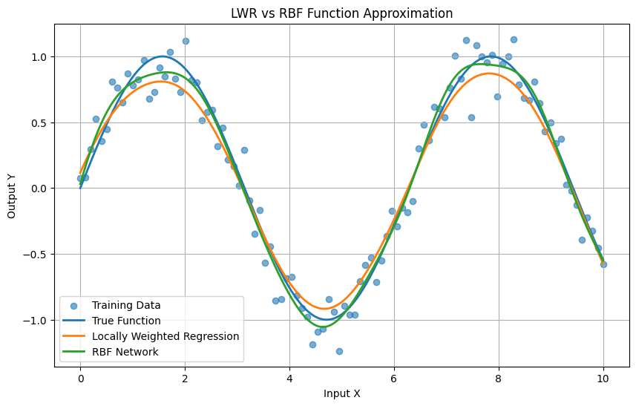

CONCLUSION
Locally Weighted Regression and Radial Basis Function networks are effective techniques for nonlinear function approximation.
LWR is more local and flexible, making it suitable when nearby observations are particularly important. However, its repeated local calculations can make prediction computationally expensive.
RBF networks provide a learned and generally smoother approximation. They require training and parameter selection, but after training they can perform predictions efficiently.
Hence, LWR is preferable when strong local adaptability is required, while RBF networks are preferable when a smooth and computationally efficient trained model is desired.

2) Compare Genetic Algorithms and Gradient Descent Optimization for solving optimization problems. Analyze differences in convergence behavior, ability to escape local minima, computational cost, and suitability for different types of objective functions. Provide examples where each method is more effective.
To compare Genetic Algorithms (GA) and Gradient Descent (GD) for solving optimization problems and analyze their differences in convergence behavior, ability to escape local minima, computational cost, and suitability for different types of objective functions.

INTRODUCTION
Optimization is the process of finding the best solution to a problem by minimizing or maximizing an objective function. Optimization techniques are widely used in machine learning, engineering, scheduling, robotics, and data science.
Two important optimization methods are Genetic Algorithms and Gradient Descent.
A Genetic Algorithm is a population-based optimization technique inspired by natural selection and evolution. It uses operations such as selection, crossover, and mutation to search for better solutions.
Gradient Descent is an iterative mathematical optimization method. It uses the gradient or derivative of an objective function to move toward a minimum value.
Although both methods can solve optimization problems, their behavior is quite different.

GENETIC ALGORITHM
A Genetic Algorithm is a stochastic optimization technique inspired by biological evolution.
A population of possible solutions, called chromosomes, is initially generated. Each solution is evaluated using a fitness function.
The basic steps are:
- Generate an initial population.
- Calculate the fitness of each solution.
- Select better solutions.
- Perform crossover.
- Apply mutation.
- Create a new population.
- Repeat until a stopping condition is reached.

MAIN GENETIC ALGORITHM OPERATIONS
Selection:
Selects better solutions for reproduction.
Crossover:
Combines two parent solutions to generate new solutions.
Mutation:
Randomly changes parts of a solution to maintain diversity.
Fitness:
Measures how good a particular solution is..

GRADIENT DESCENT
Gradient Descent is an iterative optimization algorithm that uses the gradient of an objective function.
For a parameter x, the update rule is:
xnew=xold−ηdf(x)dxx
where:
- x = parameter
- η = learning rate
- df(x)dx = gradient of the objective function
The algorithm repeatedly moves in the direction opposite to the gradient because this direction decreases the objective function.
m=y2−y1x2−x1
BASIC STEPS
- Initialize the parameters.
- Calculate the gradient.
- Update the parameters.
- Calculate the new objective value.
- Repeat until convergence.

Convergence Behavior
The convergence behavior of GA and GD is different.

Genetic Algorithm
GA searches using a population of solutions. Several areas of the search space can be explored simultaneously. However, because it uses random operations, convergence is usually slower and may fluctuate between generations.

Gradient Descent
GD follows the gradient toward a minimum. For smooth and convex functions, it can converge rapidly and reliably.
Therefore:
GA → slower but broader exploration
GD → faster but more dependent on the local landscape

Ability to Escape Local Minima
One of the major differences is the ability to escape local minima.
Gradient Descent normally follows the local gradient. If it reaches a local minimum, it may stop there even when a better global minimum exists.
GA maintains a population of solutions and uses mutation and crossover. These operations allow it to explore different regions of the search space.
Therefore:
Method | Ability to Escape Local Minima
Genetic Algorithm | High
Gradient Descent | Low to Moderate
GA is generally more suitable when the objective function contains many local minima.

COMPUTATIONAL COST
Genetic Algorithms evaluate many candidate solutions in every generation. Therefore, the number of objective-function evaluations can be large.
Gradient Descent generally updates one parameter vector at a time and can therefore be much cheaper for smooth mathematical functions.
Factor | Genetic Algorithm | Gradient Descent
Number of solutions | Population | Usually one solution
Objective evaluations | High | Lower
Derivatives required | No | Yes
Computation per iteration | High | Relatively low
Convergence speed | Usually slower | Usually faster

SUITABILITY FOR OBJECTIVE FUNCTIONS
The type of objective function strongly influences which algorithm should be selected.

Genetic Algorithm is suitable for:
- Non-differentiable functions
- Discontinuous functions
- Noisy objective functions
- Combinatorial optimization
- Discrete variables
- Problems with many local minima
- Complex search spaces

Gradient Descent is suitable for:
- Smooth functions
- Differentiable functions
- Convex optimization
- Machine-learning model training
- Neural-network optimization
- Large-scale continuous optimization
PYTHON CODE:

import numpy as np
import matplotlib.pyplot as plt
# Objective function
def f(x):
return x**2 + 10 * np.sin(5 * x)
# Gradient Descent
def gradient(x):
return 2 * x + 50 * np.cos(5 * x)
def gradient_descent(x, learning_rate=0.001, iterations=1000):
history = []
for i in range(iterations):
x = x - learning_rate * gradient(x)
history.append(x)
return x, history
# Genetic Algorithm
def genetic_algorithm():
population_size = 50
generations = 100
mutation_rate = 0.1
# Initial population
population = np.random.uniform(-5, 5, population_size)
best_history = []
for generation in range(generations):
fitness = f(population)

# Select best half
indices = np.argsort(fitness)
parents = population[indices[:population_size // 2]]
# Store best solution
best = parents[0]
best_history.append(best)
# Create new population
new_population = list(parents)
while len(new_population) < population_size:
# Select parents
p1 = np.random.choice(parents)
p2 = np.random.choice(parents)
# Crossover
child = (p1 + p2) / 2
# Mutation
if np.random.random() < mutation_rate:
child += np.random.normal(0, 0.5)
# Keep within limits
child = np.clip(child, -5, 5)
new_population.append(child)
population = np.array(new_population)

best_x = population[np.argmin(f(population))]
return best_x, best_history
# Run Gradient Descent
gd_x, gd_history = gradient_descent(
x=4,
learning_rate=0.001,
iterations=1000
)
# Run Genetic Algorithm
ga_x, ga_history = genetic_algorithm()
# Display Results
print("----- Optimization Results -----")
print("Gradient Descent:")
print("Best x =", round(gd_x, 4))
print("Minimum value =", round(f(gd_x), 4))
print("\nGenetic Algorithm:")
print("Best x =", round(ga_x, 4))
print("Minimum value =", round(f(ga_x), 4))
# Plot Objective Function
x = np.linspace(-5, 5, 1000)
plt.figure(figsize=(10, 6))
plt.plot(x, f(x), label="Objective Function")
plt.scatter(
gd_x,
f(gd_x),
label="Gradient Descent"
)
plt.scatter(
ga_x,
f(ga_x),
label="Genetic Algorithm"
)
plt.xlabel("x")
plt.ylabel("f(x)")
plt.title("Genetic Algorithm vs Gradient Descent")
plt.legend()
plt.grid(True)
plt.show()
plt.figure(figsize=(10, 6))
plt.plot(
range(len(gd_history)),
[f(x) for x in gd_history],
label="Gradient Descent"
)
plt.plot(
range(len(ga_history)),
[f(x) for x in ga_history],
label="Genetic Algorithm"
)
plt.xlabel("Iteration / Generation")
plt.ylabel("Objective Function Value")
plt.title("Convergence Comparison")
plt.legend()
plt.grid(True)
plt.show()

----- Optimization Results -----
Gradient Descent:
Best x = 3.4282
Minimum value = 1.8473

Genetic Algorithm:
Best x = -0.3117
Minimum value = -9.9021
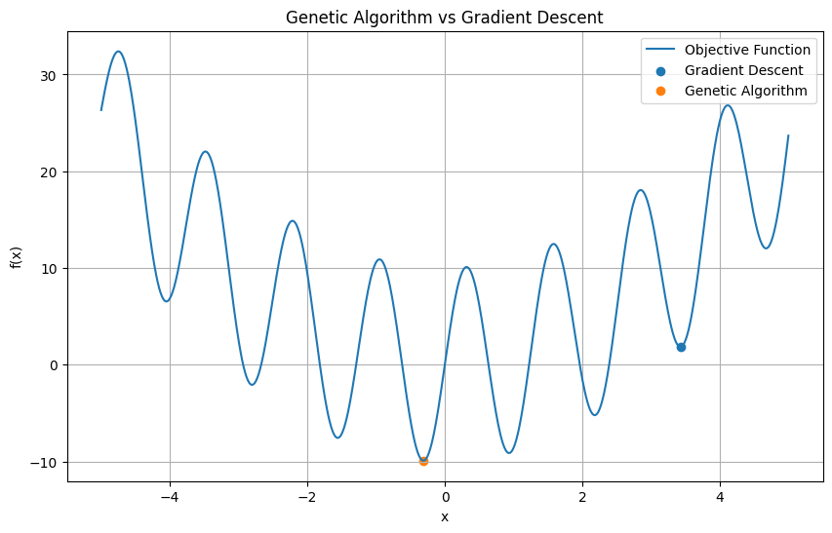
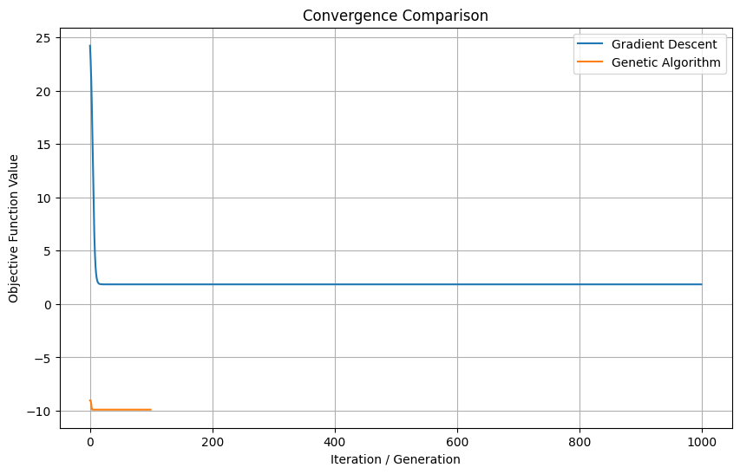

EXAMPLE 1 – GRADIENT DESCENT MORE EFFECTIVE
Consider the objective function:
f(x)=(x−3)2
The minimum occurs at:
x=3
The function is smooth, convex, and differentiable.
Its derivative is:
f′(x)=2(x−3)
Gradient Descent can quickly move toward x=3
For this type of problem, Gradient Descent is more effective than GA because it requires fewer computations and can converge rapidly.

APPLICATION EXAMPLE
Training a linear regression model is an example where gradient-based optimization is highly effective because the objective function is smooth and differentiable.

Example 2 – Genetic Algorithm More Effective
Consider an objective function with several local minima:
f(x)=x2+10sin(5x)
Such a function has multiple peaks and valleys.
Gradient Descent may converge to a nearby local minimum depending on its starting point.
A Genetic Algorithm can maintain multiple candidate solutions and explore different regions of the function.
Therefore, GA is more suitable for this type of complex multimodal optimization problem.

Application Example
A scheduling problem where tasks must be assigned to machines can involve discrete variables and many possible combinations. A GA can be more suitable because derivatives are not naturally available.

CONCLUSION
Genetic Algorithms and Gradient Descent are powerful optimization techniques, but they are designed for different types of problems.
Genetic Algorithms provide broad exploration of the search space and have a strong ability to escape local minima. They do not require derivatives and are particularly useful for discrete, discontinuous, noisy, or highly multimodal optimization problems. However, they generally require more computational resources and converge more slowly.
Gradient Descent is computationally efficient and converges quickly for smooth, differentiable objective functions. It is one of the most important optimization methods used in machine learning and neural-network training. However, it can become trapped in local minima and requires suitable gradients and learning-rate selection.
Therefore, Gradient Descent is generally preferred for smooth continuous optimization and machine learning, whereas Genetic Algorithms are more appropriate for complex, non-differentiable, discrete, or multimodal optimization problems.

3)Compare Random Forest and Decision Tree algorithms using a classification problem such as credit risk assessment. Analyze differences in overfitting control, accuracy, interpretability, and robustness to noisy data. Discuss how ensemble learning in Random Forest improves generalization compared to a single decision tree.

Comparison of Random Forest and Decision Tree for Credit Risk Assessment

AIM
To compare Decision Tree and Random Forest classification algorithms for credit risk assessment and analyze their differences in overfitting control, accuracy, interpretability, and robustness to noisy data.

INTRODUCTION
Decision Tree is a supervised machine learning algorithm used for classification and regression. It makes decisions by splitting the dataset based on important features. In credit risk assessment, it can classify customers as Low Risk or High Risk using factors such as income, credit score, loan amount, and repayment history.
Random Forest is an ensemble learning algorithm that combines multiple Decision Trees. Each tree is trained using different samples and subsets of features. The final prediction is obtained by combining the predictions of all trees.

DECISION TREE
A Decision Tree has a tree-like structure consisting of a root node, decision nodes, branches, and leaf nodes.
For example:
Credit Score > 700?
- Yes → Low Risk
- No → Check Income
  - High Income → Low Risk
  - Low Income → High Risk

ADVANTAGES
- Easy to understand and interpret.
- Requires little data preprocessing.
- Fast to train.
- Useful when decision rules need to be explained.

DISADVANTAGES
- Can easily overfit the training data.
- Sensitive to noisy data.
- Small changes in data can produce a different tree.
- May have lower generalization performance.

RANDOM FOREST
Random Forest creates many Decision Trees and combines their predictions. For classification, the final class is generally selected using majority voting.
For example, if 10 trees predict:
- 7 trees → Low Risk
- 3 trees → High Risk
The Random Forest predicts Low Risk.

ADVANTAGES
- Reduces overfitting compared with a single tree.
- Usually provides higher accuracy.
- More robust to noisy data.
- Handles many input features effectively.
- Provides better generalization.

DISADVANTAGES
- More computationally expensive than one tree.
- More difficult to interpret.
- Requires more memory because many trees are stored.

Comparison
Feature | Decision Tree | Random Forest
Overfitting | High | Lower
Accuracy | Moderate | Generally higher
Interpretability | Very high | Moderate/low
Noisy data | Sensitive | More robust
Training cost | Low | Higher
Generalization | Lower | Better
Number of trees | One | Many
Prediction | Single tree | Majority voting

Credit Risk Assessment Example
Consider a bank that wants to predict whether a customer is High Risk or Low Risk.
The input features can include:
- Credit score
- Annual income
- Loan amount
- Previous payment history
- Age
A Decision Tree may learn very specific patterns from the training data. If the data contains noise, the tree can create unnecessary branches and overfit.
Random Forest reduces this problem by training multiple trees using different subsets of data and features. Since the trees make different errors, combining their predictions produces a more stable result.

Ensemble Learning and Generalization
The main advantage of Random Forest is ensemble learning. Instead of depending on one Decision Tree, it combines many trees.
Each tree sees a different random sample of the training data and a different subset of features. The final prediction is obtained by combining their results.
This reduces the effect of individual tree errors and decreases variance. As a result, Random Forest generally generalizes better to unseen data than a single Decision Tree.
PYTHON CODE:

# Random Forest vs Decision Tree
# Credit Risk Classification
import pandas as pd
from sklearn.model_selection import train_test_split
from sklearn.tree import DecisionTreeClassifier
from sklearn.ensemble import RandomForestClassifier
from sklearn.metrics import accuracy_score, classification_report
data = {
"CreditScore": [750, 680, 620, 800, 590, 710, 650, 780,
560, 720, 640, 690, 810, 600, 730, 670,
580, 760, 630, 700],
"Income": [70000, 50000, 30000, 90000, 25000, 65000, 40000,
85000, 22000, 72000, 35000, 55000, 95000, 28000,
68000, 45000, 24000, 80000, 32000, 60000],

"LoanAmount": [20000, 30000, 40000, 15000, 50000, 25000,
35000, 18000, 55000, 22000, 45000, 30000,
12000, 48000, 20000, 38000, 52000, 16000,
42000, 25000],
# 0 = Good repayment history
# 1 = Poor repayment history
"LatePayments": [0, 1, 2, 0, 3, 0, 1, 0, 4, 0,
2, 1, 0, 3, 0, 1, 4, 0, 2, 1],
# 0 = Low Risk
# 1 = High Risk
"Risk": [0, 0, 1, 0, 1, 0, 0, 0, 1, 0,
1, 0, 0, 1, 0, 0, 1, 0, 1, 0]
}
df = pd.DataFrame(data)
X = df.drop("Risk", axis=1)
y = df["Risk"]
X_train, X_test, y_train, y_test = train_test_split(
X, y,
test_size=0.30,
random_state=42
)
dt = DecisionTreeClassifier(
max_depth=3,
random_state=42
)
dt.fit(X_train, y_train)
dt_prediction = dt.predict(X_test)
dt_accuracy = accuracy_score(
y_test,
dt_prediction
)
rf = RandomForestClassifier(
n_estimators=100,
max_depth=3,
random_state=42
)
rf.fit(X_train, y_train)
rf_prediction = rf.predict(X_test)
rf_accuracy = accuracy_score(
y_test,
rf_prediction
)
print("----- Credit Risk Classification -----")
print("Decision Tree Accuracy:",
round(dt_accuracy * 100, 2), "%")
print("Random Forest Accuracy:",
round(rf_accuracy * 100, 2), "%")
print("\nDecision Tree Predictions:")
print(dt_prediction)
print("\nRandom Forest Predictions:")
print(rf_prediction)
print("\nDecision Tree Report:")
print(classification_report(y_test, dt_prediction))
print("\nRandom Forest Report:")
print(classification_report(y_test, rf_prediction))

RESULT:
----- Credit Risk Classification -----

Decision Tree Accuracy: 100.0 %
Random Forest Accuracy: 100.0 %

Decision Tree Predictions:
[0 0 0 0 1 0]

Random Forest Predictions:
[0 0 0 0 1 0]

Decision Tree Report:
precision recall f1-score support

0 1.00 1.00 1.00 5
1 1.00 1.00 1.00 1

accuracy 1.00 6
macro avg 1.00 1.00 1.00 6
weighted avg 1.00 1.00 1.00 6

Random Forest Report:
precision recall f1-score support

0 1.00 1.00 1.00 5
1 1.00 1.00 1.00 1

accuracy 1.00 6
macro avg 1.00 1.00 1.00 6

weighted avg 1.00 1.00 1.00 6

CONCLUSION
A Decision Tree is simple, fast, and highly interpretable, but it can overfit and is sensitive to noisy data. Random Forest combines multiple trees and therefore provides better accuracy, robustness, and generalization.
For credit risk assessment, Random Forest is generally more suitable when prediction performance is the main goal, while a Decision Tree is useful when the decision process must be easily explained.

4) Compare Linear Regression and Polynomial Regression for predicting housing prices. Analyze differences in model complexity, ability to capture non-linear relationships, risk of overfitting, and interpretability. Discuss scenarios where each model performs better.

AIM
To compare Linear Regression and Polynomial Regression for predicting housing prices and analyze their differences in model complexity, ability to capture non-linear relationships, overfitting, and interpretability.

INTRODUCTION
Regression is a supervised machine learning technique used to predict a continuous output. In housing price prediction, the price of a house can be predicted using features such as area, number of bedrooms, and age of the house.
Linear Regression assumes that the relationship between the input and output is approximately linear. Polynomial Regression extends Linear Regression by adding polynomial terms such as x2, x3, etc., allowing the model to represent curved relationships.

LINEAR REGRESSION
Linear Regression represents the relationship between input and output using a straight-line equation:
y=b0+b1x
where yy is the predicted house price and xx can represent house area.

ADVANTAGES
- Simple and easy to understand.
- Low computational cost.
- Highly interpretable.
- Less likely to overfit when the relationship is approximately linear.
- Works well when house price increases approximately proportionally with area.

DISADVANTAGES
- Cannot effectively represent complex non-linear relationships.
- May underfit data containing curves or changing trends.

POLYNOMIAL REGRESSION
Polynomial Regression uses additional powers of the input:
y=b0+b1x+b2x2+⋯+bnxn
For example, a degree-2 model is:
y=b0+b1x+b2x2
This allows the prediction curve to bend and capture non-linear relationships.

ADVANTAGES
- Captures non-linear relationships.
- More flexible than Linear Regression.
- Can provide better predictions when the data follows a curved pattern.

DISADVANTAGES
- More complex than Linear Regression.
- Higher-degree polynomials can overfit.
- Less interpretable.
- Computational cost increases as the polynomial degree increases.

COMPARISON
Feature | Linear Regression | Polynomial Regression
Model complexity | Low | Higher
Relationship | Linear | Non-linear
Interpretability | Very high | Moderate
Overfitting risk | Low | Higher
Computational cost | Low | Moderate/High
Flexibility | Low | High
Suitable for | Simple trends | Curved trends

Housing Price Example
Consider a dataset containing house area and house price.
If the price increases almost linearly with area, Linear Regression can provide a good prediction.
For example, if larger houses consistently cost more at a nearly constant rate, a straight line is sufficient.
However, housing prices may not always increase linearly. Prices may increase rapidly for larger houses or may level off after a certain area. Polynomial Regression can capture such curved relationships.

Overfitting
Linear Regression has a relatively simple structure, so it generally has a lower risk of overfitting.
Polynomial Regression becomes increasingly flexible as the degree increases. A high-degree polynomial may fit almost every training data point but perform poorly on new houses. This is known as overfitting.
Therefore, a suitable polynomial degree should be selected using validation or testing data.

WHEN EACH MODEL PERFORMS BETTER

Linear Regression is better when:
- The relationship between area and price is approximately linear.
- The dataset is small and simple.
- Interpretability is important.
- Low computational cost is required.

Polynomial Regression is better when:
- The relationship between features and price is non-linear.
- The data contains a clear curved pattern.
- Linear Regression underfits the data.
- More flexibility is required.
PYTHON CODE;

import numpy as np
import matplotlib.pyplot as plt
from sklearn.linear_model import LinearRegression
from sklearn.preprocessing import PolynomialFeatures
from sklearn.metrics import mean_squared_error
# House area in square feet
X = np.array([
500, 700, 900, 1100, 1300,
1500, 1700, 1900, 2100, 2300
]).reshape(-1, 1)
# House price in lakhs
y = np.array([
25, 31, 38, 45, 53,
62, 72, 84, 97, 112
])
linear_model = LinearRegression()
linear_model.fit(X, y)
y_linear = linear_model.predict(X)
poly = PolynomialFeatures(degree=2)
X_poly = poly.fit_transform(X)
poly_model = LinearRegression()
poly_model.fit(X_poly, y)
y_poly = poly_model.predict(X_poly)
linear_mse = mean_squared_error(y, y_linear)
poly_mse = mean_squared_error(y, y_poly)
print("----- Housing Price Prediction -----")
print("Linear Regression MSE:",
round(linear_mse, 2))
print("Polynomial Regression MSE:",
round(poly_mse, 2))
new_house = np.array([[1800]])
linear_prediction = linear_model.predict(new_house)
new_house_poly = poly.transform(new_house)
poly_prediction = poly_model.predict(new_house_poly)
print("\nPrediction for 1800 sq.ft house:")
print("Linear Regression:",
round(linear_prediction[0], 2),
"lakhs")
print("Polynomial Regression:",
round(poly_prediction[0], 2),
"lakhs")
X_plot = np.linspace(500, 2300, 200).reshape(-1, 1)
linear_plot = linear_model.predict(X_plot)
poly_plot = poly_model.predict(
poly.transform(X_plot)
)
plt.figure(figsize=(10, 6))
plt.scatter(
X,
y,
label="Actual House Prices"
)
plt.plot(
X_plot,
linear_plot,
label="Linear Regression"
)
plt.plot(
X_plot,
poly_plot,
label="Polynomial Regression"
)
plt.xlabel("House Area (sq.ft)")
plt.ylabel("Price (Lakhs)")
plt.title("Linear vs Polynomial Regression")
plt.legend()
plt.grid(True)
plt.show(

OUTPUT:
----- Housing Price Prediction -----
Linear Regression MSE: 16.3
Polynomial Regression MSE: 0.37

Prediction for 1800 sq.ft house:
Linear Regression: 80.87 lakhs
Polynomial Regression: 78.54 lakhs
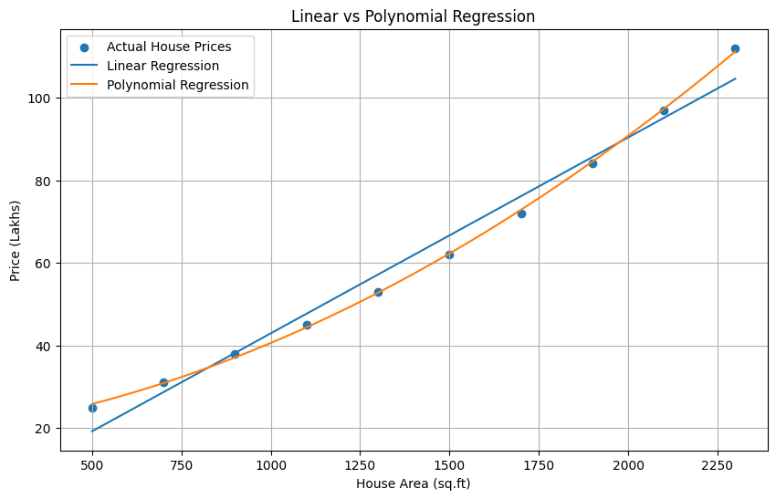

CONCLUSION
Linear Regression is simple, fast, and easy to interpret, making it suitable for housing datasets with approximately linear relationships.
Polynomial Regression is more flexible and capable of capturing non-linear relationships, but its complexity increases the risk of overfitting.
Therefore, Linear Regression should be preferred for simple linear housing-price trends, while Polynomial Regression is more suitable when the relationship between house features and price is clearly non-linear.

5) Compare K-Means Clustering and DBSCAN using a dataset with irregular cluster shapes. Analyze differences in cluster detection, handling of noise and outliers, requirement of parameters, and scalability. Discuss how each algorithm performs in real-world clustering tasks.

Aim
To compare K-Means Clustering and DBSCAN using a dataset containing irregularly shaped clusters and analyze their differences in cluster detection, noise handling, parameter requirements, and scalability.

Introduction
Clustering is an unsupervised machine learning technique used to group similar data points without predefined class labels.
K-Means divides data into a predefined number of clusters based on the distance between data points and cluster centers.
DBSCAN (Density-Based Spatial Clustering of Applications with Noise) groups points based on their density. It can identify clusters with irregular shapes and can classify isolated points as noise.

K-Means Clustering
K-Means divides the dataset into K clusters. Each data point is assigned to the nearest cluster centroid, and the centroids are repeatedly updated until the clusters become stable.

Advantages
- Simple and easy to implement.
- Fast for large datasets.
- Works well for spherical and well-separated clusters.
- Computationally efficient.

Disadvantages
- Requires the number of clusters KK in advance.
- Performs poorly with irregularly shaped clusters.
- Sensitive to outliers.
- Results can depend on initial centroid positions.

DBSCAN
DBSCAN groups points based on their density. It uses two main parameters:
- eps: Maximum distance between neighboring points.
- min_samples: Minimum number of points required to form a dense region.
Points that do not belong to any dense region are classified as noise or outliers.

Advantages
- Can detect irregular and complex cluster shapes.
- Does not require the number of clusters in advance.
- Handles noise and outliers effectively.
- Useful for spatial and real-world datasets.

Disadvantages
- Choosing suitable eps and min_samples can be difficult.
- Performance can decrease when clusters have very different densities.
- Can be less effective in very high-dimensional data.

COMPARISON
Feature | K-Means | DBSCAN
Cluster shape | Best for spherical clusters | Handles irregular shapes
Number of clusters | Must specify K | Not required
Noise handling | Poor | Very good
Outlier handling | Sensitive | Identifies outliers
Parameters | K | eps, min_samples
Scalability | Very good | Good
Initialization | Centroid dependent | Density based
Complex clusters | Poor | Excellent

Irregular Cluster Example
Consider a dataset containing two curved or moon-shaped clusters.
K-Means assumes that clusters are based around central points. Therefore, it may divide the curved groups incorrectly.
DBSCAN uses density rather than cluster centers. It can follow the curved structure of the data and correctly identify the two irregular clusters.
Thus, for irregular cluster shapes, DBSCAN generally performs better than K-Means.

Noise and Outliers
K-Means assigns every data point to a cluster. Therefore, an extreme outlier can affect the position of a centroid and reduce clustering quality.
DBSCAN can identify isolated points as noise. These points are not forced into a cluster, making DBSCAN more robust when the dataset contains outliers.

Parameter Requirements
K-Means requires the number of clusters, K, to be specified before training.
DBSCAN does not require the number of clusters, but it requires suitable values for eps and min_samples.
Therefore, both algorithms require parameter selection, but the parameters have different meanings.

Scalability
K-Means is generally faster and scales well to large datasets, especially when the number of clusters is small.
DBSCAN can also handle reasonably large datasets, but its computational cost can increase depending on the distance calculations and dataset structure.
For very large datasets with simple, well-separated clusters, K-Means is often preferred. For datasets containing irregular shapes and noise, DBSCAN may provide better clustering quality.
PYTHON CODE:

import numpy as np
import matplotlib.pyplot as plt

from sklearn.datasets import make_moons
from sklearn.cluster import KMeans, DBSCAN

# -----------------------------------------
# 1. Create Irregular-Shaped Dataset
# -----------------------------------------

X, y = make_moons(
n_samples=500,
noise=0.08,
random_state=42
)

# Add some outliers
outliers = np.array([
[2.5, 1.5],
[-1.5, 0.5],
[2.8, -0.5]
])

X = np.vstack((X, outliers))

# -----------------------------------------
# 2. K-Means Clustering
# -----------------------------------------

kmeans = KMeans(
n_clusters=2,
random_state=42,
n_init=10
)

kmeans_labels = kmeans.fit_predict(X)

# -----------------------------------------
# 3. DBSCAN Clustering
# -----------------------------------------

dbscan = DBSCAN(
eps=0.2,
min_samples=5
)

dbscan_labels = dbscan.fit_predict(X)

# -----------------------------------------
# 4. Display Results
# -----------------------------------------

print("----- Clustering Comparison -----")

print("K-Means Number of Clusters:",
len(set(kmeans_labels)))

print("DBSCAN Number of Clusters:",
len(set(dbscan_labels)) -
(1 if -1 in dbscan_labels else 0))

print("DBSCAN Noise Points:",
list(dbscan_labels).count(-1))

# -----------------------------------------
# 5. Plot K-Means
# -----------------------------------------

plt.figure(figsize=(8, 6))

plt.scatter(
X[:, 0],
X[:, 1],
c=kmeans_labels
)

plt.title("K-Means Clustering")
plt.xlabel("Feature 1")
plt.ylabel("Feature 2")
plt.grid(True)

plt.show()

# -----------------------------------------
# 6. Plot DBSCAN
# -----------------------------------------

plt.figure(figsize=(8, 6))
plt.scatter(
X[:, 0],
X[:, 1],
c=dbscan_labels
)
plt.title("DBSCAN Clustering")
plt.xlabel("Feature 1")
plt.ylabel("Feature 2")
plt.grid(True)

plt.show()

OUTPUT:
----- Clustering Comparison -----
K-Means Number of Clusters: 2
DBSCAN Number of Clusters: 2
DBSCAN Noise Points: 3
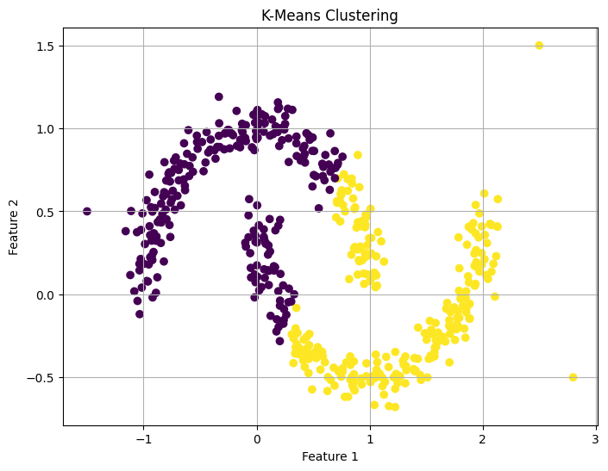
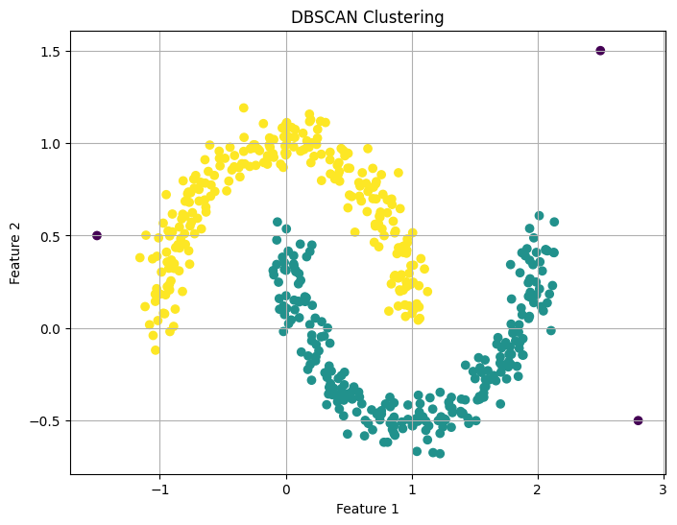

CONCLUSION
K-Means and DBSCAN are useful clustering algorithms, but they work differently.
K-Means is simple, fast, and scalable, but it works best when clusters are roughly spherical and the number of clusters is known.
DBSCAN is better for irregularly shaped clusters and noisy datasets because it is density-based and can identify outliers.
Therefore, K-Means is preferred for large datasets with clear, compact clusters, while DBSCAN is more suitable for real-world datasets containing irregular shapes and noise.

RUBRICS FOR CALCULATION

Criteria | Weightage | Level 4 – Exemplary (5 Marks) | Level 3 – Proficient (4 Marks) | Level 2 – Developing (2–3 Marks) | Level 1 – Beginning (0–1 Mark)
Conceptual Understanding | 30 | Demonstrates clear and complete understanding of the concept | Good understanding with minor gaps | Basic understanding with some misconceptions | Poor or incorrect understanding
Accuracy of Answer | 15 | Completely correct answer with no errors | Mostly correct with minor errors | Partially correct with noticeable errors | Incorrect or irrelevant answer
Application of Knowledge | 20 | Correctly applies concepts to solve the question/problem | Applies concepts with minor mistakes | Limited or partially correct application | No or incorrect application
Completeness of Response | 20 | Covers all required parts of the question | Covers most parts with minor omissions | Covers only some parts | Incomplete or missing response
Clarity & Presentation | 15 | Clear, concise, and well-organized answer | Understandable with minor issues | Somewhat unclear or poorly structured | Difficult to understand

